**SpeakFluent**

# User Manual

# Contents

Student User Manual 2

1. Registration 2

2. Enrolment 3

2.1 Changing Enrolment 3

3. Dashboard 4

4. Taking a Test 5

5. Viewing Feedback 6

2.2 Pitch Visualisation 6

2.3 Task Results 6

6. Password Reset 7

7. Allowing Microphone Access 8

Teacher User Manual

1. Create Unit ………………………………………………………………………………………………………………9

2. Create New Task…………………………………………………………………………………………………….10

3. Edit Task and Add Questions………………………………………………………………………………….12

4. Mark Tests……………………………………………………………………………………………………………..13

5. Release Marks and Download File………………………………………………………………………….14

# Student User Manual

## Registration

At the start of each semester, you will need to create a new account. At the bottom of the login box follow the link *Click here to register!*

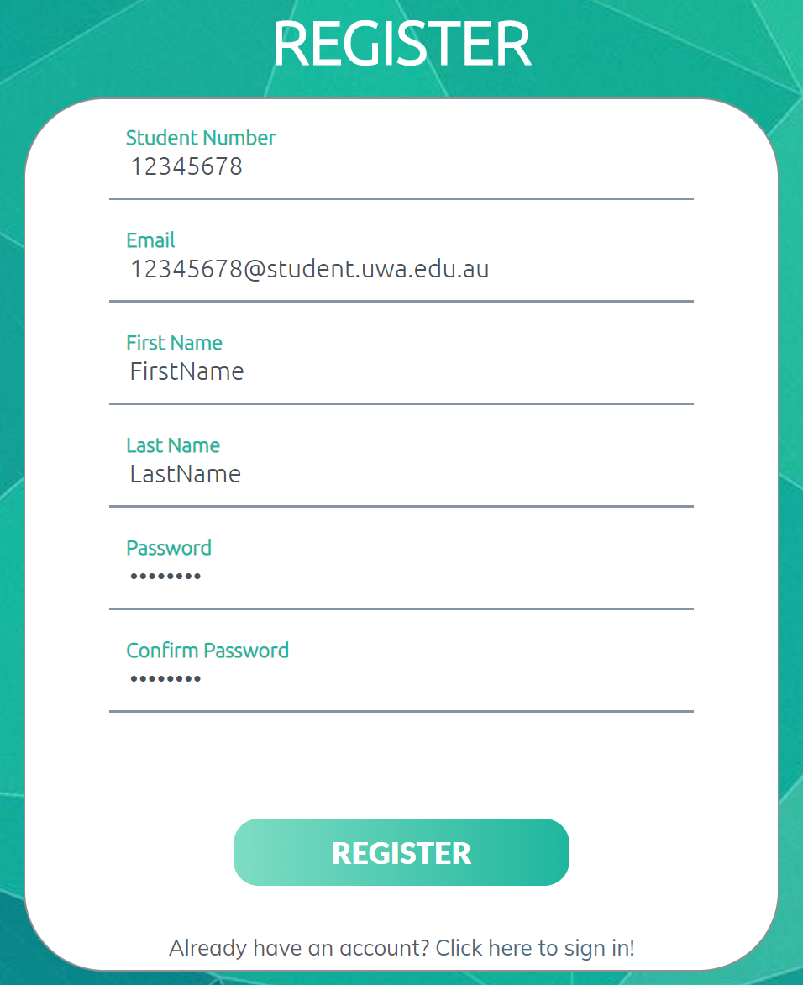

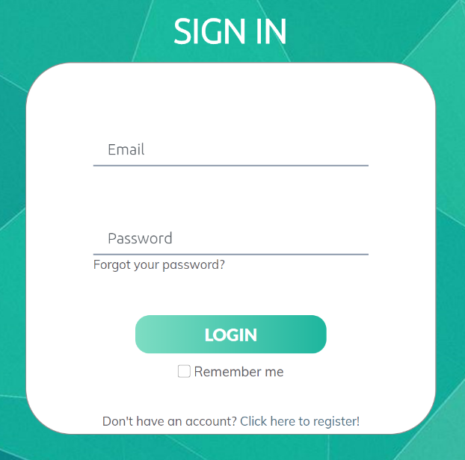

You will be required to input your student ID, student email and full name. Please also create and confirm a new password.

Ensure that the correct email is entered, and a verification link will be sent to your email.

Remember to verify your account, otherwise you will not be able to login.

Once complete, click *Register*, and you will be taken back to the login page.

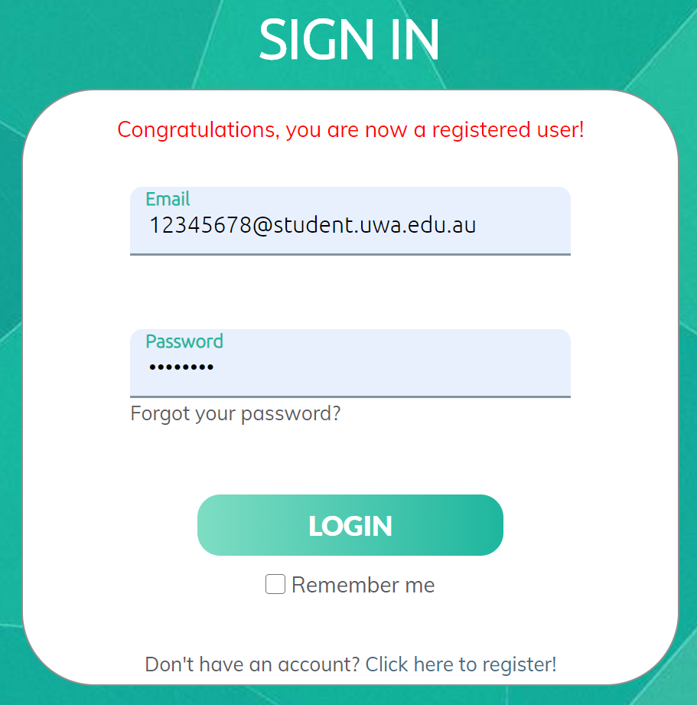

## Enrolment

When you first login as a new user, you will be taken straight to the Enrolment page.

Click the green *Enrol* button next to the correct unit.

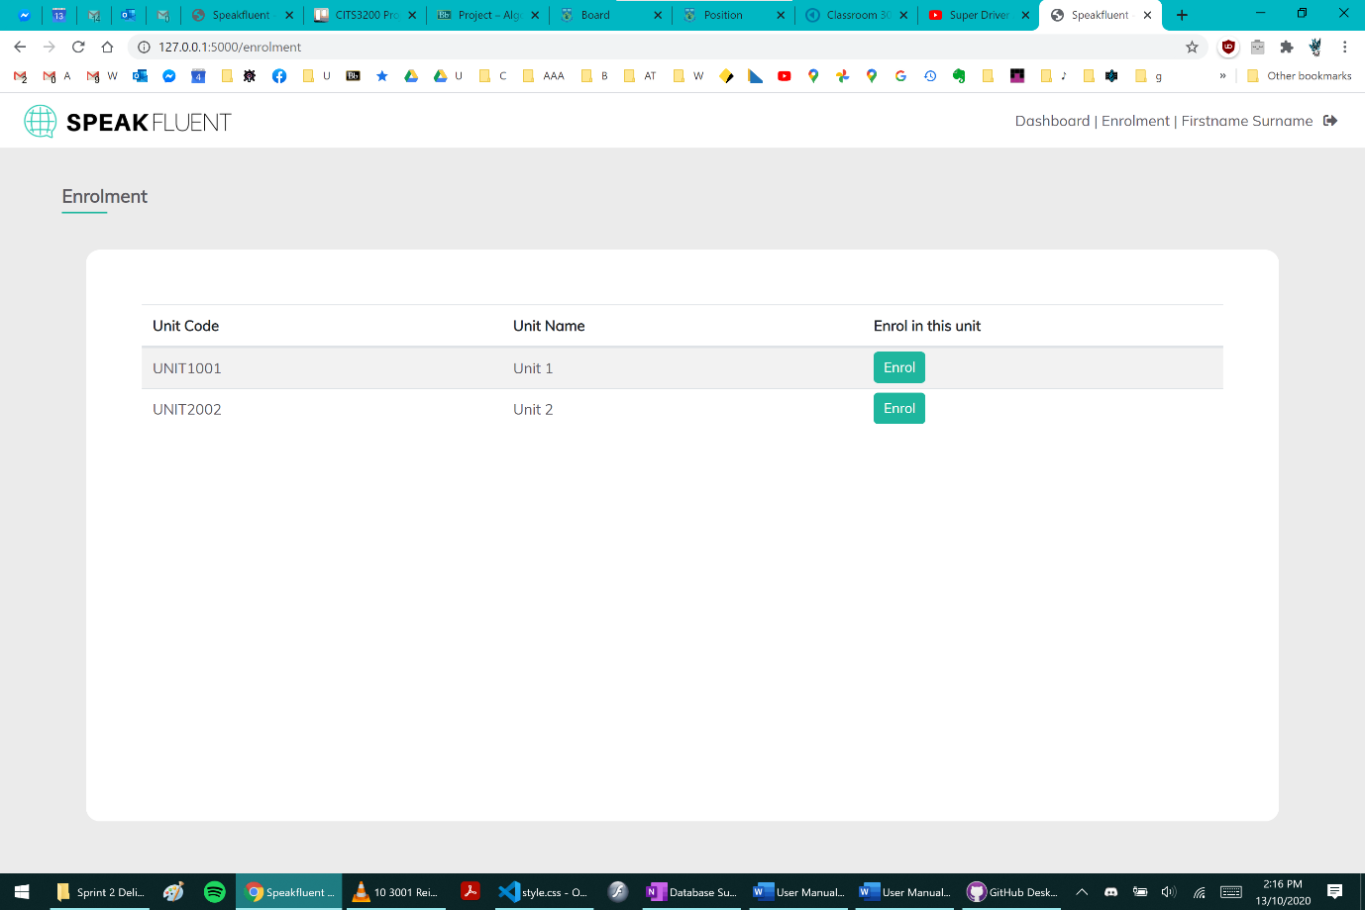

### Changing Enrolment

If you need to change units, simply click the *Enrolment* link at the top right corner.

Note that if you try to re-enrol in a previous unit, your past submissions and marks will still be there.

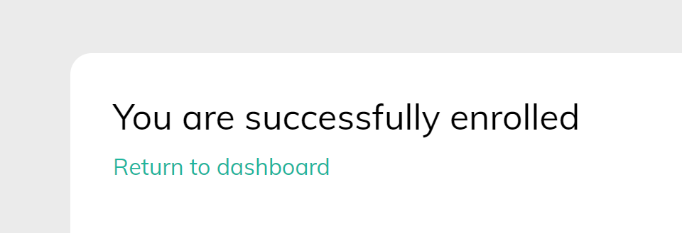

## Dashboard

The dashboard is where you access the list of all the tasks which have been created by your unit coordinator. Once you are enrolled, you will automatically be directed to the dashboard after you login, but it can also be accessed via the *Dashboard* link at the top right corner.

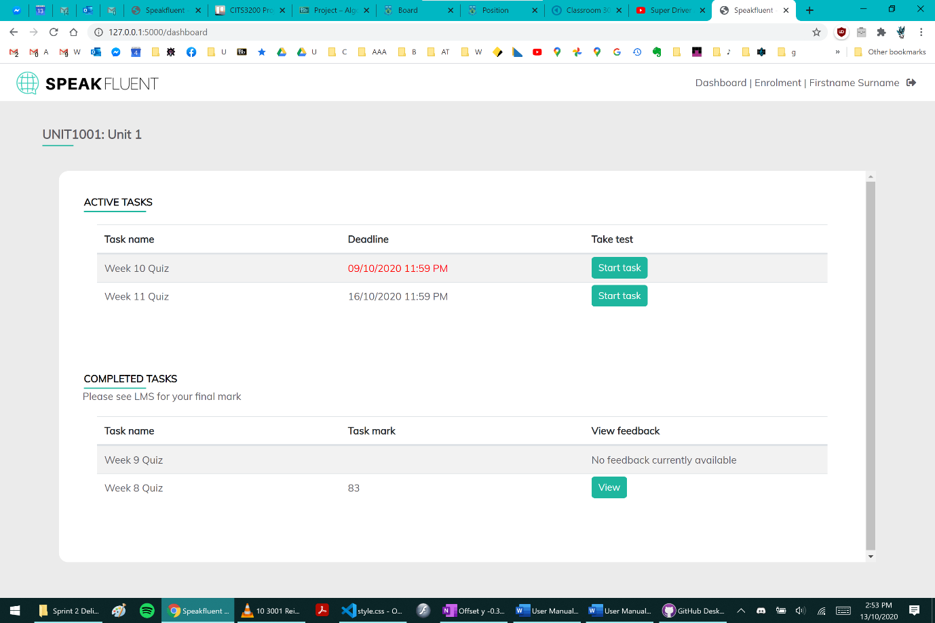

Under *Active Tasks*, you will see tasks which you have not yet attempted. Tasks past the deadline will be indicated in red text.

Under *Completed Tasks,* you will see tasks which you have already submitted. In the *View feedback* column, you may see two options: *No feedback currently available*, or the *View* button which indicates feedback has been released for all students for this task.

Note, if there are any late submission penalties, these will only be shown on LMS.

## Taking a Test

On the Dashboard, click the green *Start task* button next to an active task to view the task instructions. At this stage you are still able to leave the page, but once you click the *Start Test* button you will have to complete the entire test.

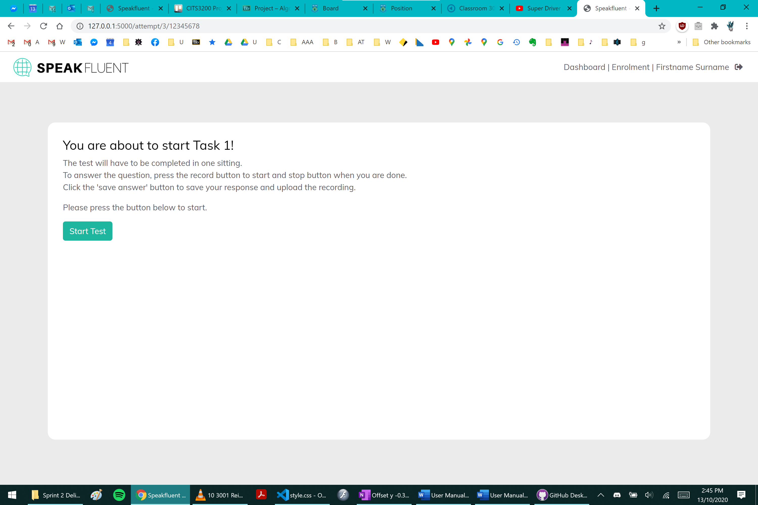

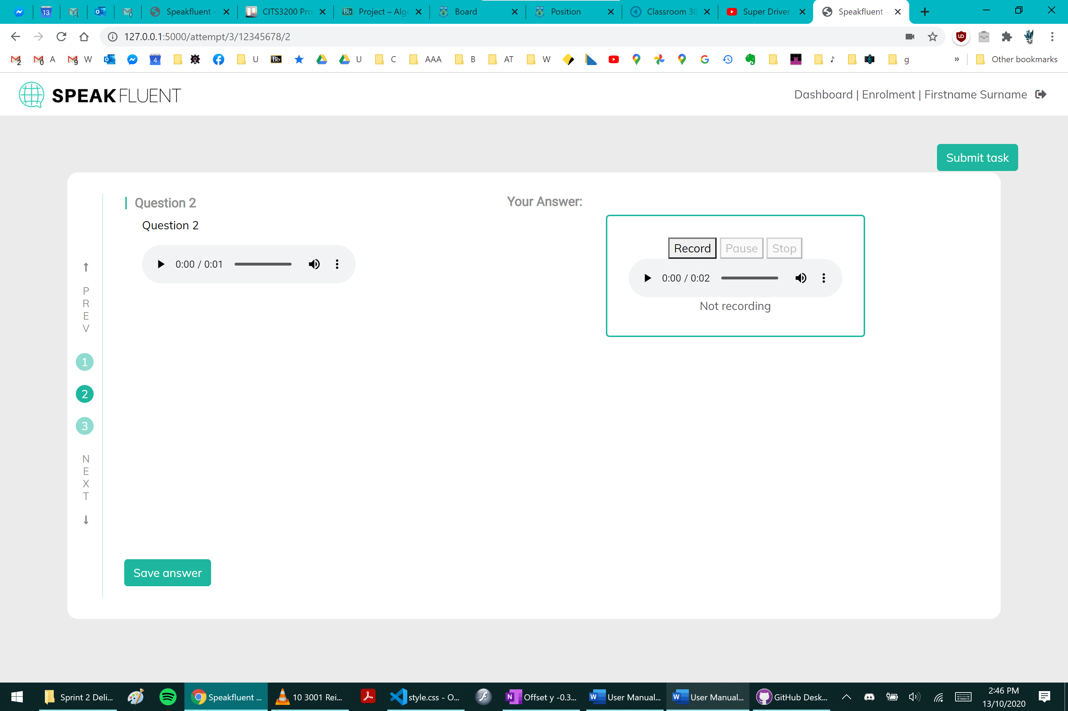

Make sure you click the *Stop* button after recording, otherwise your answer will not be uploaded.

You may make multiple recordings, but only the last recording will be submitted. However, you may download any of your recordings before overwriting them. Click the 3 dots icon on the recorder and click *Download*.

You may also use the ↑*PREV* and *↓NEXT* buttons or the numbered icons on the left to jump to any question, but before moving onto the next question always click *Save answer*.

Click *Submit task* once you have completed all questions.

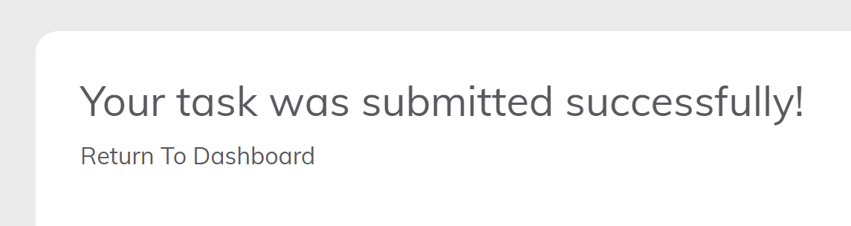

## Viewing Feedback

On the Dashboard, click the green *View* button next to a completed task. For each question you may see the teacher’s written feedback and/or audio feedback on the right.

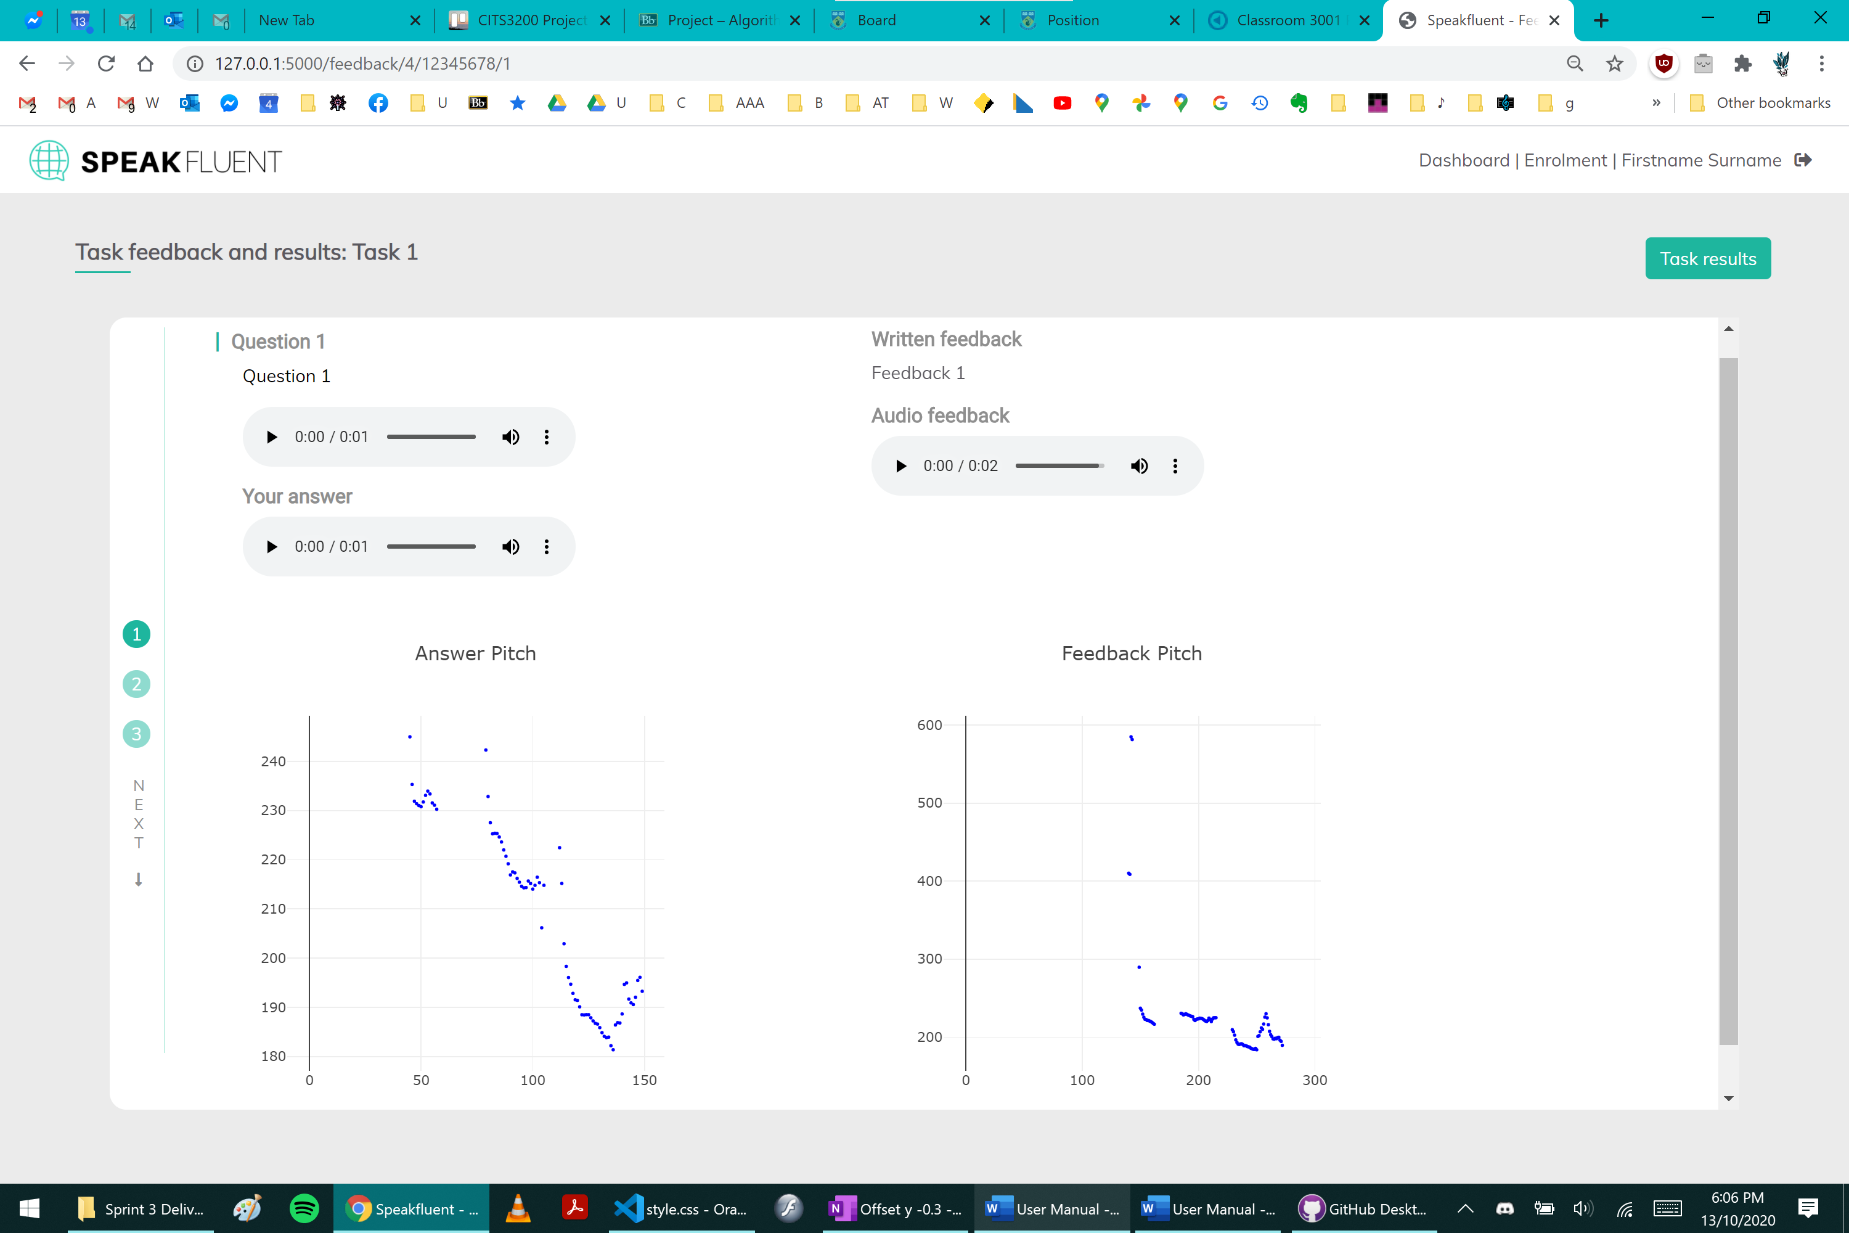

### Pitch Visualisation

The pitch visualisation graph compares the contours of your audio to the teacher’s audio feedback. There are several options to change the view of each graph. It may be useful to select a box around a specific section of the graph to zoom in.

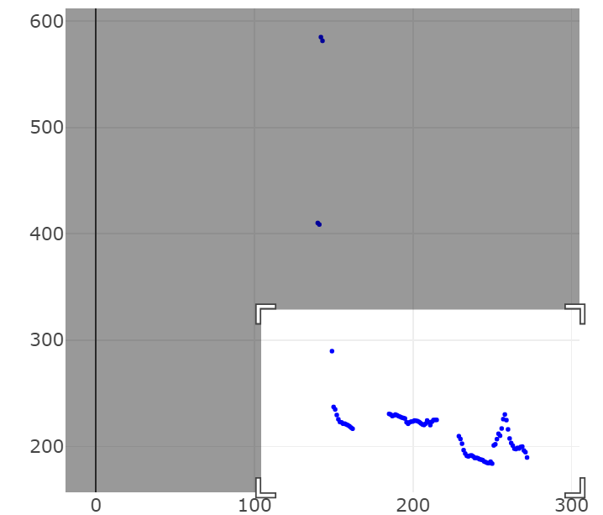→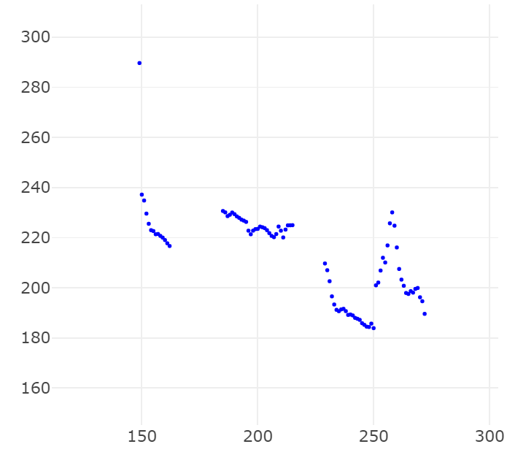

### Task Results

Click the green *Task Results* button in the top right corner to bring up a popup.

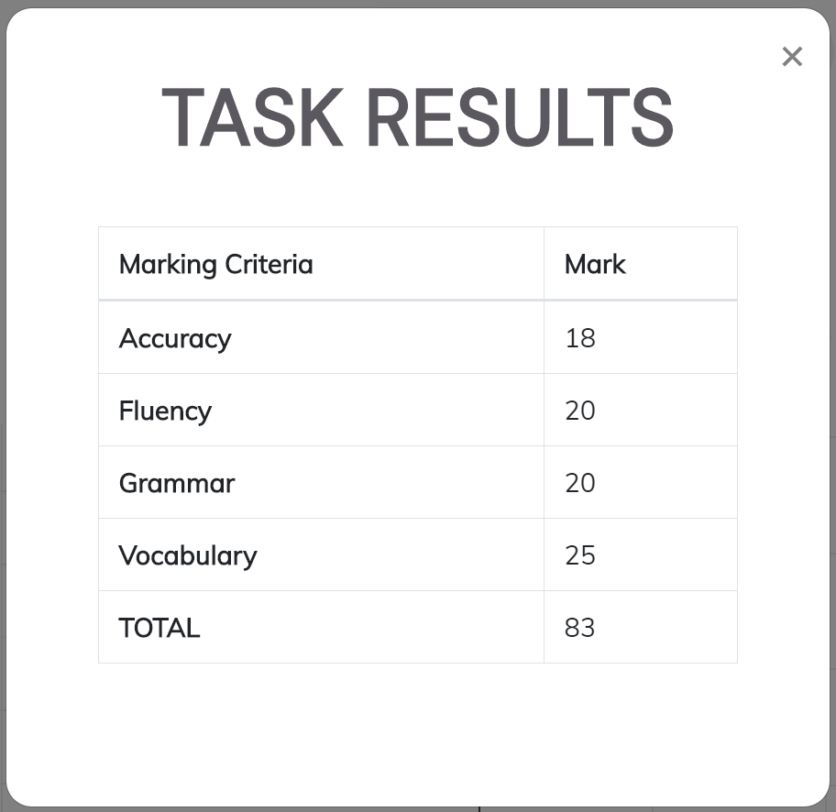

## Password Reset

If you forget your password, simply click the *Forgot your password?* link. You will be redirected to a new page to enter your student email, then click *Request Password Reset.*

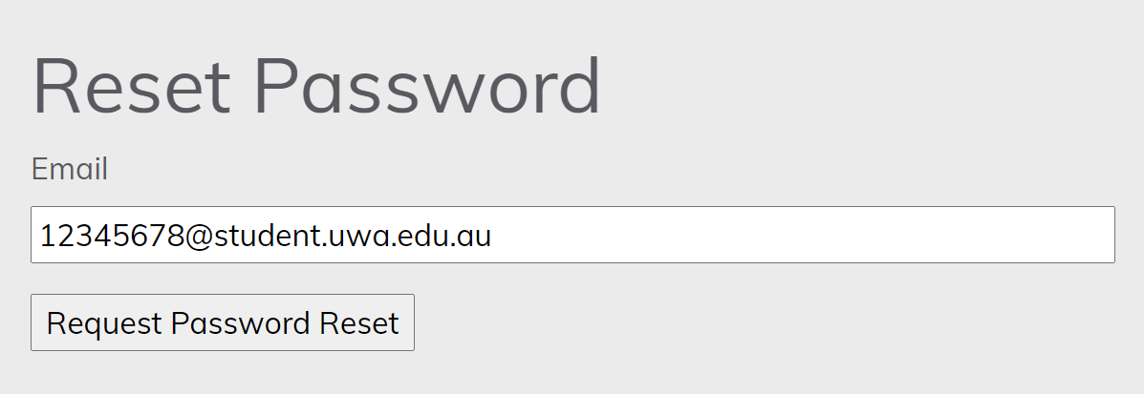

You may need to check your Junk Email. Click the link in the email to be taken to the password reset page. Type your new password, then click *Request Password Reset*.

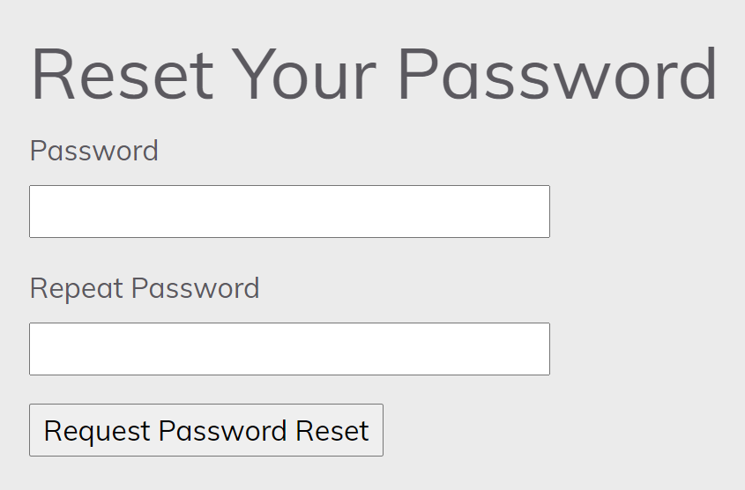

You will be redirected to the login page with a message confirming the password reset.

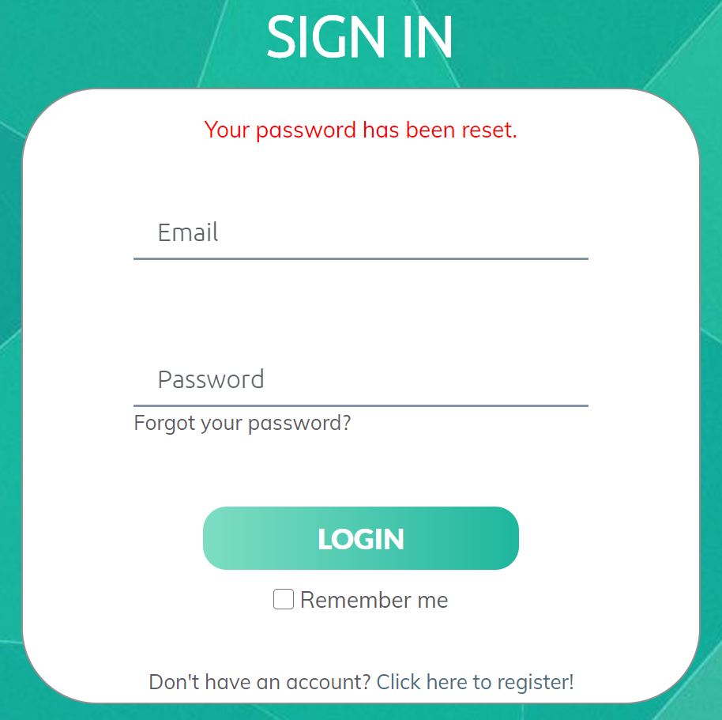

## Allowing Microphone Access

Your answers will be audio recordings which requires access to the microphone from your device.

It is recommended to use Google Chrome for this application.

In normal circumstances when you attempt a task, it will automatically ask for permission to use your device’s microphone. Click *Allow*.

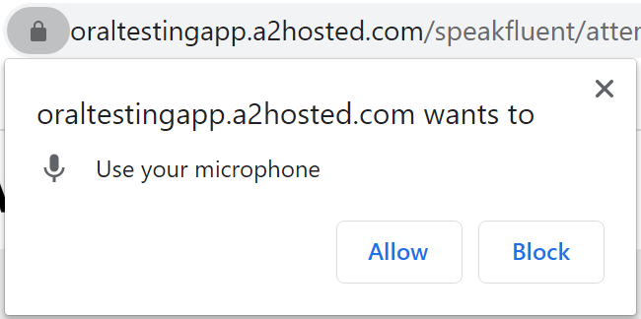

However, in situations where it does not, please read the following steps:

In the address bar of your web browser, press the icon to the left of the address. This is usually a padlock icon or an info icon. Next click the dropdown menu next to Microphone and select *Allow*.

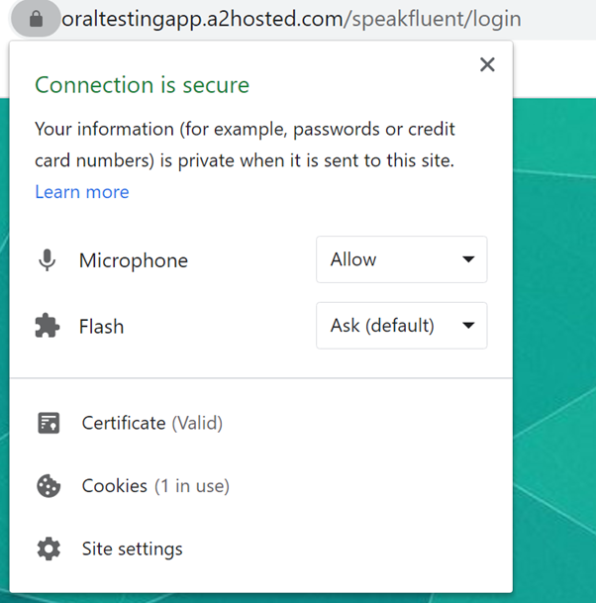

**Teacher Manual**

**\*Please check Page 2 for Registration and Page 8 for Microphone Access**

**1.Create Unit**

When you login for the first time in a new semester, your dashboard will look like th first picture where you will have to create the unit you are going to teach.

For this you will press the button on the top right, ‘New Unit’, which will lead you to pop up page as shown in the second picture. Here as the unit-coordinator you will have to enter details of the unit you will be teaching this semester, like the Unit Code, Unit details and the criteria based on which you want to mark the students. Since this an language test application, some sample criteria have been given like Fluency, Accuracy etc.

After, the unit is created you will be redirected to your dashboard with the list of all your available units. You have the option to select from the list of available units which will lead to unit dashboard or there is also the option to delete the unit, if there has been a mistake while creating or there have not been enough student and the unit has to be discontinued.

**2.Create New Task**

The unit dashboard has multiple list, and options to create new tests and the ability to manage students. The manage students option leads the teacher to another page which contains the list of all the people who are currently enrolled in the unit with their full name and student ID.

To create new tests/tasks, similar to creating a new unit press the button on the top right, which will lead to a pop-up page. This page only stores basic and necessary information about the test like the test name, the due date and the last time for submission.

**3.Add Test Questions**

The previous page only creates the basic information about a test and not the any questions. For this, you will have to click the on the edit button from the above list for which you want to add questions.

On this page you can add questions, and for better user experience there is not a set number of questions, the teacher can create whatever number of questions required.

Moreover, the process for question creation, is that if the teacher wants there can create oral questions, this means that instead of writing the question, the teacher can record themselves for the purposes of increasing listening skills as well. Moreover, if needed the teacher can add both oral and written parts to the same question, this can be used if they want to provide some hint or extra information. **A screenshot of a computer
**

**4.Mark Tests**

Lastly after all the questions are created, you will be returned to the specific Unit Manager page, where if happy with the questions you can release the test.

* The teacher has the option to create all the tests for the semester in the first week itself and they can then release the test basis on their suited timeline .

On the Same Unit Manager page , after the due date has lapsed, the teacher will have the option to grade the answers.

To achieve this they will click on the test name, which leads to another page with the list of all the students. Here by clicking on a student they will hear check the answers and at the end of checking they will be required to grade based on the criteria set up in the beginning.

**5.Release Marks and Download Marks File**

After the grading of all the student has been completed, the teacher can return the Unit Manager page, and click on release feedback. This will release the grade and marks released to all the students.

Lastly there since the actual database for grading is LMS, after enough time has passed, the teacher can download a csv file by clicking on the button.

This CSV file can then be uploaded on LMS which will automatically enter the grades for all student and the teacher would not have to manually enter feedback and grades.